**Contrasting effects of host or local specialization: widespread haemosporidians are host generalist, whereas local specialists are locally abundant**

Figure S1: Distribution of localities where haemosporidian parasites have been recorded. These comprise a total of 757 localities (including offshore islands) extracted from the MalAvi database

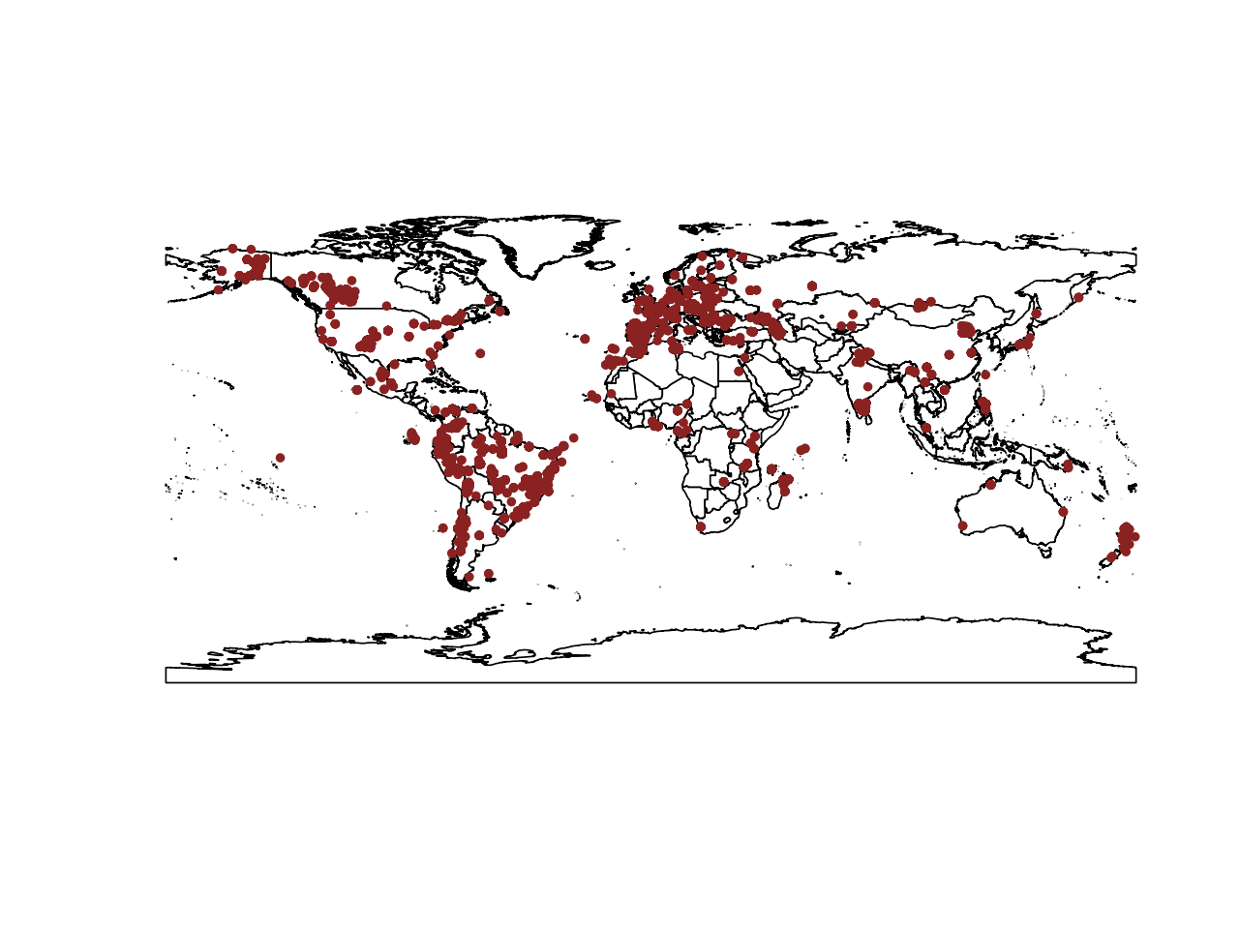

Figure S2: Principal component analyses (PCA) for environmental heterogeneity among localities in Europe and South America. Each point represents a locality. Information regarding environmental heterogeneity was extracted from WorldClim.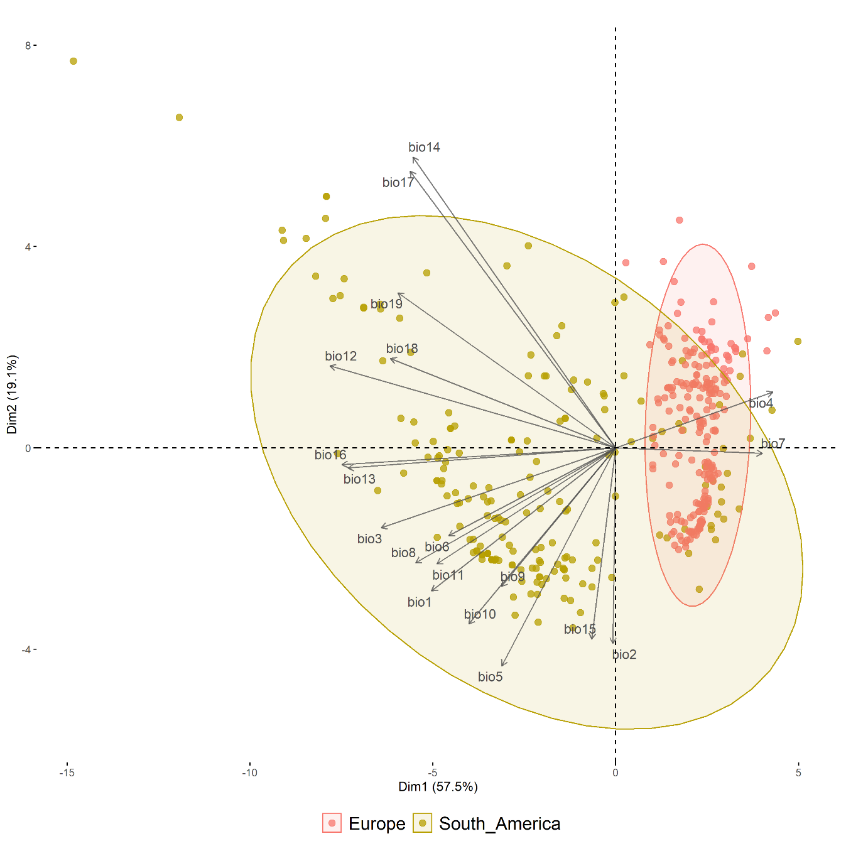

Table S2: Parameter estimates, standard errors, and confidence intervals for the PGLS model testing the relationship between the host phylogenetic range of *Plasmodium* spp. and their geographical range.

|  |  |  |  |  |
| --- | --- | --- | --- | --- |
|  | Estimate | Stand. Error | T value | P value |
| Intercept | -0.06 | 1.13 | -0.06 | 0.95 |
| Host phylogenetic range | 0.73 | 0.08 | 9.02 | <0.001 |
| Occurrences per area | -0.33 | 0.06 | -5.68 | <0.001 |
| Total occurrences | 0.10 | 0.07 | 1.39 | 0.16 |

Table S3: Parameter estimates, standard errors, and confidence intervals for the PGLS model testing the relationship between the host phylogenetic range of *Plasmodium* spp. and their environmental range.

|  |  |  |  |  |
| --- | --- | --- | --- | --- |
|  | Estimate | Stand. Error | T value | P value |
| Intercept | 0.11 | 0.98 | -0.12 | 0.90 |
| Host phylogenetic range | 0.38 | 0.07 | 5.32 | <0.001 |
| Occurrences per area | -0.33 | 0.05 | -6.54 | <0.001 |
| Total occurrences | 0.54 | 0.06 | 8.51 | <0.001 |

Table S4: Parameter estimates, standard errors, and confidence intervals for the PGLS model testing the relationship between the host phylogenetic range of *Haemoproteus* spp. and their geographical range.

|  |  |  |  |  |
| --- | --- | --- | --- | --- |
|  | Estimate | Stand. Error | T value | P value |
| Intercept | 0.53 | 1.88 | 0.28 | 0.78 |
| Host phylogenetic range | 0.40 | 0.08 | 4.68 | <0.001 |
| Occurrences per area | -0.01 | 0.08 | -0.16 | 0.87 |
| Total occurrences | 0.05 | 0.04 | 1.14 | 0.25 |

Table S5: Parameter estimates, standard errors, and confidence intervals for the PGLS model testing the relationship between the host phylogenetic range of *Haemoproteus* spp. and their environmental range.

|  |  |  |  |  |
| --- | --- | --- | --- | --- |
|  | Estimate | Stand. Error | T value | P value |
| Intercept | -1.87 | 1.78 | -1.05 | 0.29 |
| Host phylogenetic range | 0.35 | 0.08 | 4.33 | <0.001 |
| Occurrences per area | -0.29 | 0.07 | -3.81 | <0.001 |
| Total occurrences | 0.27 | 0.04 | 5.94 | <0.001 |